Player Name_______________________________________________________ Grade ________________
Company Name________________________________________________________________
Company Address ______________________________________________________________
Contact Name ______________________________________Phone______________________
Email (Required) _______________________________________________________________

Sponsor Banner Options: Premier Banner Options:
$700 - One Banner $2,500 - One Banner
$1,400 - Two Banners (Limited Availability)
$2,100 - Three Banners

*Make checks payable to: Bingham High School Boys Lacrosse (No Personal Checks)
2160 W. 10400 S. South Jordan, Ut 84095

All sponsor banners will be hung at the home field and sponsors will be recognized by the announcer at home games, featured on are Instagram @binghamminerslacrosse and Web Page www.binghamlacrosse.com
**Premium banners will be hung on Team Box “Premium Location”!

Banner Artwork:

Company supplies new banner artwork at correct size and layout (Vector File of Logo).
*Please direct all questions about company information needed for the banner to Tom Moon. See contact information below.
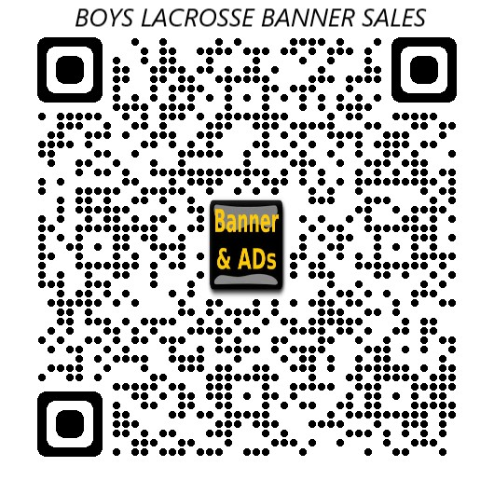
Renew existing banner.

Banner Questions and artwork submissions:
Contact Tom Moon
Email: tmoon801@gmail.com
Call or Text Phone #: 801-633-6333
Or Denae Carlson
Text or Call: 719-287-9644

Submit Form, Check (or follow QR code for payment), and Artwork by Friday, February 2nd, 2024

Thank you for supporting Bingham Boys Lacrosse!

