2024 BHS LAX

Bingham Lacrosse Coaches
V
Brett HC bretteverill@gmail.com
Keiton Jones
Brady Jacobsen
Cody Elmen
JV
Danny Dupaix HC
Todd Young
Dom Tschaggeny
Caleb Ives

DOLO and CC and V:
Matt Cheeks
Development and CC and JV:
Brent Bailey

Aux/Specialty Coaches
Brayden Rudd
Brennan Chalmers
Jordan Whitney
Devan Nyguen

Team Partners:
Nom Nutrition
7 Point Nutrition
Athletic Performance Labs
Athlecare

Team Theme: RELENTLESS

Team Book: The Gold Standard by Coach K
https://www.amazon.com/The-Gold-Standard-Mike-Krzyzewski-audiobook/dp/B0023AP7XA/ref=sr_1_1?hvadid=409997016947&hvdev=c&hvlocphy=9029724&hvnetw=g&hvqmt=e&hvrand=10650050654678399932&hvtargid=kwd-157713440239&hydadcr=24629_11409997&keywords=the+gold+standard+coach+k&qid=1701227332&sr=8-1
Please purchase a copy or get the E book. We will read throughout the season.

Important Dates for Spring 2024

December 4th | Study Hall 6:00 PM
December 5th | Winter Camp begins (Tuesday & Thursday 6PM-9PM) $35.00
December 7th | Store Closes
January 16th | First day of weights and conditioning (Monday-Thursday 6PM-9PM) $175.00
January 19th | Top 10 begins
February 12th-26th | 2 weeks prior restrictions. (Captain/Player practices and conditioning) M,W,TH
February 26th-27th | Tryouts 7:00 - 9:30 PM at the stadium
February 28th | Team Selection (V and JV)
March 2nd | Mandatory Team Event, Stats Training, Bus Treat Assembly
March 4th | Uniform Handout
March 5th | Team Pictures & Blue and White game or VS Alumni
March 6th  March 8th | Email Campaign & Stats Training  First Game against Weber JV Only
March 9th | Weber Tournament
March 25th-31st | Spring Break !!!
April 1st | Mandatory First practice after the break (We have a game on the 2nd)
May 2nd | Senior Night against Herriman
May 4th | The Lax Formal
May 11th | State Tournament Bracket Reveal and Breakfast
May 13th-25th | State Tournament Playoffs
May 28th | Team Banquet & Alumni Game
May 29th | Ring Selection and Design
TBD | Concussion testing will be after Tryouts
TBD | Physical session at Bingham is usually the first week of March

Expectations- Be There!
Everything is outlined in the BHS LAX code of conduct.
This will be issued after team selections.
Attendance- Players are expected to be at all Lacrosse functions on time.
Players receive a 1-time excusal for any event with no penalty.
Beyond the 1-time excused absence, players will miss 1 quarter for every event missed.
For any event missed, including the excused absence, please use the following QR code below.

Absence Form
https://forms.gle/VJUrJFRsaVQWrkxj6

Spring Store Closes on 12-07-23
https://binghamboyslax2324.itemorder.com/
*All Optional and additional items can be ordered from the school store. Spirit pack items will come from the school once all fees are paid.
These items will be sent to school and sent home with the player.
In season practices
No 8th period this year.
All days from 6:00 PM to 9:30 PM @ Bingham
(Saturday’s will be morning)

Registration for Winter camp & clinic
Dec. 5th – 14th
Tuesdays and Thursdays 6:00 PM to 9:00 PM.
It will be at Bingham in the film room, weight room, gym and on the track.
Register prior to attending. Forms are turned into the office.
Cost is $35.00.
(Bring cleats, sticks, helmets, gloves and gym shoes. We will be inside and out Most likely outside)

Registration for Spring camp & clinic
January 16th – February 8th
Monday-Thursday 6:00 PM to 9:00 PM.
It will be at Bingham in the film room, weight room, gym and on the track.
Register prior to attending. Forms are turned into the office.
Cost is $175.00.
(Bring cleats, sticks, helmets, gloves and gym shoes. We will be inside and out)

WINTER CLINIC | SPRING CLINIC
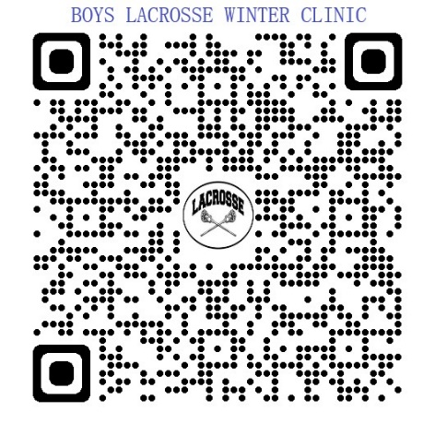 | 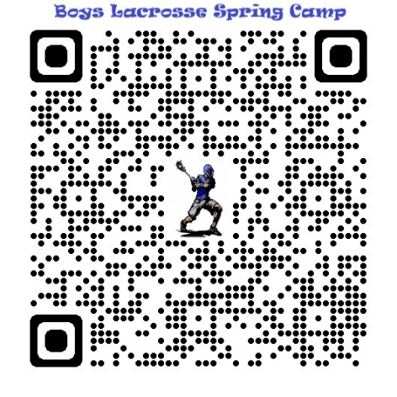

Registration for tryouts
Register for tryouts on Aktivate (formerly register my athlete)
https://www.registermyathlete.com/login/

Grade checks that night
Grade checks will be done for Quarter 2. Must have a 2.0 or Higher Only 1 F or 1 Incomplete

Spirit Pack Fees
Participation Fee: $250.00
Practice Uniform/Pennies: $65.00
Team Short and Shooter Jersey: $120.00
Travel Jacket and Pants: $90.00
Team Socks: $17.00
Team Polo: $50.00
(Must be paid prior to first game)
Total: $592.00

Volunteers (Will be coordinated by Hillaree Jones)
Stats-Spotters and Statisticians are needed for every V and JV game, home and away.
Filming- Filming of away games as needed.
Bus Treats- Bus treats for away games.

Team Dinners- will be once a week when games start. 8:00 PM on Wednesdays.

Lax Formal- Boys and Girls HS team dance.

Senior Night- Last regular season home game.

Locker Room Decoration- Make the smelly locker room look amazing.

Game Schedule- Is on MaxPreps and in TeamSnap
https://www.maxpreps.com/ut/south-jordan/bingham-miners/lacrosse/schedule/

For most games
V starts at 5:30 PM
JV starts at 7:30 PM
Warm up 1 hour prior
Every player will ride the bus to and from the schools.

Fundraising (Coordinated by Tom Moon)
Fundraising & Sponsors
Banner donations/applications to be submitted by the 2nd of February. Players that receive any fundraising money for the program will receive 50% of that amount to go towards their spirit pack and team fees. There will be no refunds on these donations, even if there is extra or for the student does not make the team)
Prizes will be awarded to the player(s) that bring in the most money.
Email Campaign
March 6th 7:00 PM (BHS Cafeteria)
We will have an email campaign at the school one night where everyone will reach out to their network proving them a link to donate to the program for a specific player.
Prizes will be awarded to the player(s) that bring in the most money.

Team Platforms/Communication
Teamsnap
Teamsnap is our main form of communication for chat, schedules, updates and volunteering, it is set up by team, after tryouts your player will be invited to join his team. Browser and Application

Hudl
Hudl is where all of our games are recorded. Players can watch themselves and scout other teams. Players can gather video of just themselves and create recruiting videos. Browser and Application options.

Lacrosse Labs
All of our plays and drills reside in Lax Labs. It also contains our practice plans. Browser and Application options.

Any questions?
Contact us!
binghamlaxinfo@gmail.com
bretteverill@gmail.com
801-440-2906

Text or call Denae 719-287-9644

