Hello Bingham LAX Families! Fall 2023

We are excited to get the HS club fall season rolling! This fall season begins with tryouts on September 5th.

Season Details:
Please get your player registered for fall ASAP!
Register Here: https://fs26.formsite.com/8l7WXD/zmozlzc4lh/index

Tryouts:
- Tuesday, September 5th. 5:30-7:30PM. Check-in starts at 5pm.
Location: Elk Meadows Elementary School: 3448 W. 9800 S
- BRING the 3 attached Documents (printed, and signed) with you to tryouts! Players will not be allowed on the field until all registration for the fall season is completed with fees paid.
- We will be using the SOJO LC jerseys. Please make sure you take good care of these and turn them in at the end of the season. Shorts are not included- which means you will need to wear your own shorts and socks.
- We do not provide any other lax equipment. If you need equipment, please discuss your needs with the coaches at the parent meeting.

Practices:
- Tuesday & Thursday 5:30-7:30pm
Fees: $560
- Fall season fees $300 (fees cover field rental, field striping, honey bucket, needed equipment, referee fees, etc)
- Tournament fees for 3 tournaments are $260 (Hotel, players dinner Friday night, Saturday breakfast and lunch are included in fee.)

Venmo:@Bingham-Lacrosse

PLEASE INCLUDE YOUR PLAYER’S NAME IN VENMO COMMENT!
*Fees will need to be paid via Venmo by September 5, 2023

Team Store: Link is open August 30th - September 12th and can be found on:

http://binghamlacrosse.com

Fundraiser:
Savers FUNDrive 8/7/2023 – 10/13/2023 *PLEASE USE THE FLYER*
If you have questions please contact Rita Anderson (801) 949-5091

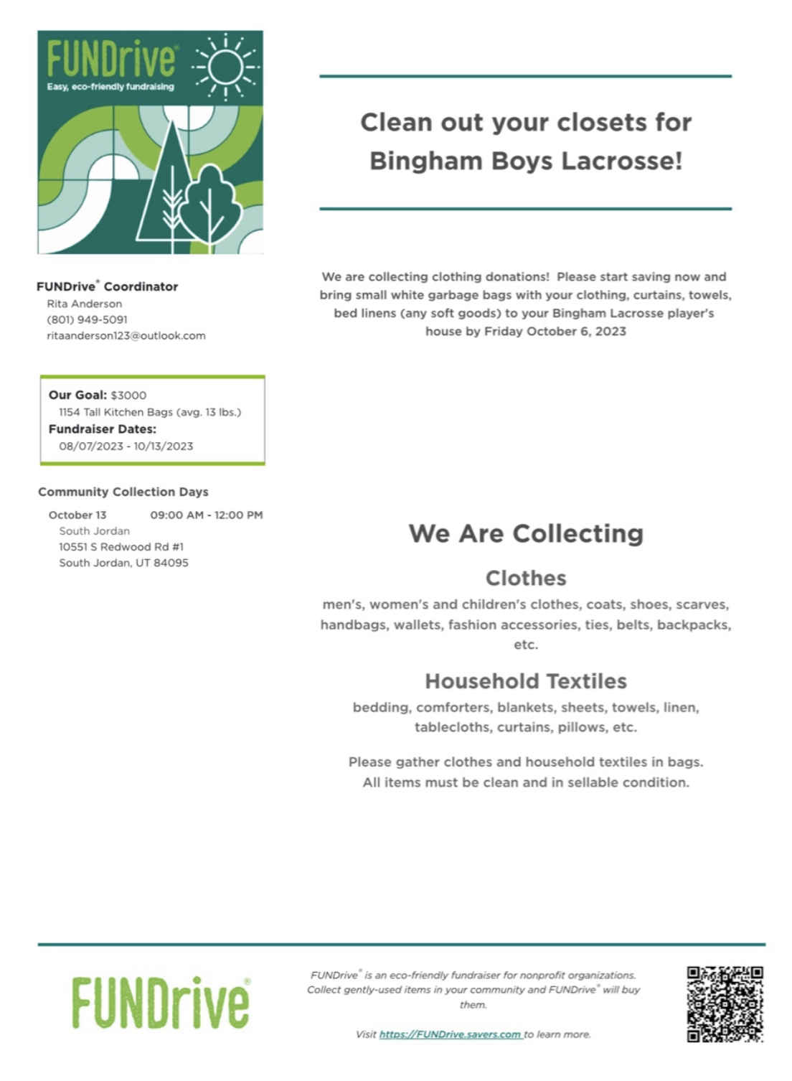

Fall Schedule 2023

Practice Tuesday and Thursday 5:30-7:30pm
- Elk Meadows Elementary- 3448 W 9800 S, South Jordan, UT 84095
Sept 5th Tryouts 5:00-7:30pm

Sept 7th First practice 5:30-7:30pm

Sept 9th Bingham vs Wasatch Varsity at 10 am and JV to follow @ Wasatch HS

Sept 15th-16th Idaho Falls tournament
- Staying at Springhill Suites 665 River Walk Dr, Idaho Falls, ID83402
Sept 15th
Varsity versus Ammon 6 pm – all games played at 4700 Sweetwater Way Ammon ID (Woodland Hills Elementary)
Dinner to follow at 7:15 pm Olive Garden catering

Sept 16th
Varsity:
Varsity versus IF/Pocatello 10:30-11:30 am (Different from Ammon field)
Varsity versus Bozeman 12:30-1:30 pm
Varsity versus Jackson Hole 2:30-3:30 pm
JV:
JV versus Jackson Hole- 9:30-10:30 am
JV versus Ammon 11:30-12:30 pm
JV versus Pocatello 1:30-2:30 pm

Sept 23rd Varsity versus Cedar Valley

Oct 13-14 Las Vegas Tournament- Finalizing the hotel Element Las Vegas Summerlin
Oct 13th
Varsity versus Bishop Gorman at Bishop Gorman high school 5:30, JV to follow
done by 8 pm-
Dinner at 7:15 for Varsity and 8:15 for JV
Oct 14th
Palo Verde- 2022 Nevada state champs and Faith Lutheran 2022 state runner up
Varsity:
Varsity at 10 am- versus Palo verde
Varsity at 12 pm at Faith Lutheran
JV:
JV at Faith Lutheran at 10 am
JV versus Palo Verde at 12 noon
- Games with Palo Verde at The Crossings Park 111 Crestdale Ln. Las Vegas NV 89144
- Games at Faith Lutheran 2015 S. Hualapai Way Las Vegas Way NV

Oct 20th - Oct 21st Mountain Ridge Tournament
- We will play Herriman, Riverton and Mountain Ridge
- Times and date pending

Working on scheduling additional fall season games.

